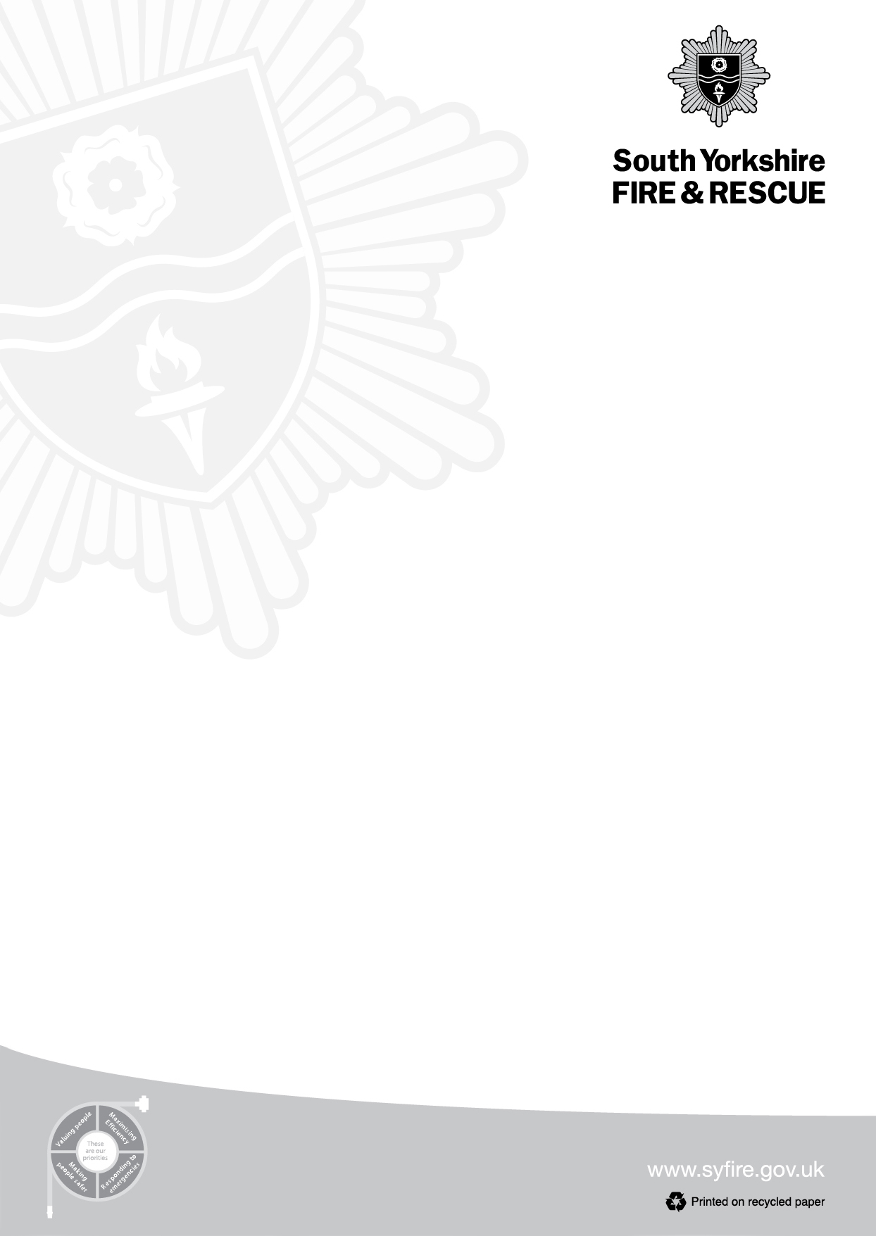

Dear Parents and Guardians,
As we experience hot and dry weather conditions, we want to share some essential fire safety messages to help protect our community and the environment. Your awareness and cooperation are crucial in preventing wildfires and ensuring everyone's safety.
Important Safety Tips:
Please leave disposable BBQs at home and consider enjoying a picnic instead.
Refrain from making campfires or lighting fires in gardens.
Dispose of cigarettes carefully and responsibly.
Ensure all litter, especially glass bottles, is taken home or disposed of properly, as they can magnify the sun’s rays and potentially start fires.
Fire Prevention Advice:
Keep gardens clear of dry, flammable materials such as garden waste to help protect your home and neighbourhood.
During hot weather, avoid burning waste in your garden, as small fires can easily spread to fences and neighbouring properties.
If you see anyone setting fires in public spaces, please contact Firestoppers anonymously at 0800 169 5558.
Safety Considerations During Hot Weather:
The ground becomes very dry during heatwaves, making it easier for fires to start and spread rapidly.
We strongly advise against burning rubbish or garden waste during this period.
When visiting parks, fields, or countryside areas, please avoid bringing disposable BBQs, as the risk of wildfires is extremely high at this time.
It is also important to talk with children at home about these safety messages. Helping them understand the potential dangers of fires and the importance of staying safe outdoors can make a significant difference. Encourage them to follow safety rules, be alert to their surroundings, and to report anything suspicious or concerning to a trusted adult.
Your vigilance and cooperation are vital in helping to prevent wildfires and maintain safety for everyone. Thank you for your support in keeping our community safe during this challenging weather.

Sincerely,
Jessica Grayson BEM
Community Safety Station Manager
South Yorkshire Fire and Rescue

