
Schools and Colleges Early Support Service:
Parent and Carer Webinars

Dear Parents and Carers,

We would like to invite you to attend the Autumn Term webinar series specially tailored for parents/carers of adolescents, in collaboration with the Schools and Colleges Early Support Service.

The topics have been chosen to reflect core developmental processes in adolescence and common difficulties parents can struggle with. The content is psychoeducational, strategy-based and solution focused. The webinars will cover the following topics:

- Low mood in adolescence
- Anxiety in adolescence: how can parents help?
- Adolescent self–harm: how to make sense of it and when to seek support
- Weathering the storms of strong teen emotions: do’s, don’ts and when to consider talking to someone
- Building resilience, staying connected and nurturing your relationship with your teen
- Managing teen behaviour that challenges: tips and tricks

Further details on each webinar are below. To register please click on the relevant Zoom link. After registering, you will receive a confirmation email containing information about joining the meeting.

Low mood in adolescence
Monday 20 November 12:15-13:15

Low mood does not just affect adults. Young people can experience low mood too. Common signs of low mood often include sadness that does not go away, feeling irritable all of the time, not being interested in things that used to be enjoyed, feeling tired and exhausted a lot of the time. Things that might increase low mood include family difficulties, bullying, bereavement, parental separation, friendship issues.
Our webinar will offer some insight into spotting the signs and symptoms of low mood, understand why young people are vulnerable to experiencing this and offer evidence-based strategies to support a young person.

Click here to register.

Anxiety in adolescence: how can parents and carers help?
Thursday 23 November 12:00-13:00

It is normal to sometimes feel anxious, however for some adolescents, anxiety can become a significant problem that stops them from doing things, e.g., talking to new people, going out with friends, or doing their best in exams. The focus of this webinar will be on what parents/carers can do to help their teens who are experiencing anxiety.
It will cover when anxiety is normal vs. problematic, common anxieties during adolescence (exam stress, social anxiety and worries about identity and development), the relationship between parent-child anxiety, and how and when to access support for you and your child. We will also discuss a couple of ‘real world’ examples of common adolescent anxieties and different strategies that may be helpful in those situations.

Click here to register.

Adolescent self–harm: how to make sense of it and when to seek support
Tuesday 7 November 17:00-18:15

Adolescence brings about many challenges, including insecurity, self-consciousness, anxiety about one’s own body, and peer pressure. It is not uncommon for teenagers to engage in some self-harmful behaviour for a period of time, for instance cutting, hair pulling or scratching. Understandably, these behaviours can be very concerning, distressing, and confusing for parents.
This webinar will provide an overview of the risk factors and methods of self-harm. It will explore the various reasons why young people may self-harm and offer ideas on how parents can talk to and support their teens. Lastly, it will discuss instances of self-harmful behaviour that may require professional support. Places on this webinar won’t be limited and there will be an opportunity to ask questions at the end.

Click here to register.

Weathering the storms of strong teen emotions: do’s, don’ts and when to consider talking to someone
Tuesday 21 November 12:30-13:30

Adolescence inherently consists of many storms that parents, families, and young people have to weather, many of which are driven by an intensity of emotions that is unique to this developmental stage. Teenagers grapple with their own identity, their social relationships, and their need for autonomy, and in turn parents face the challenge of being left out, managing their own reactions to strong teen emotions, and finding different ways of connecting with their teens.
This webinar will provide an overview of the changes adolescents go through, why teenagers experience such strong emotional fluctuations and how these are linked to processes in the brain. It will offer ideas on how to support teenager with their strong feelings and what to best avoid.
Lastly, the webinar will discuss the difference between normal emotional difficulties in adolescence and issues that may need additional support. Places on this webinar won’t be limited and there will be an opportunity to ask questions at the end.

Click here to register.

Building resilience, staying connected and nurturing your relationship with your teen
Monday 13 November 17:00-18:00

Adolescence is a time of insecurity, strong feelings and growing autonomy which naturally affects the parent-child relationship and requires parents to find new ways of connecting with their teenagers. Parents may feel left out and worried, and they may experience a sense of loss over the relationship they used to have with their children when they were younger.
This webinar offers ideas on how to maintain and build trust with teenagers, how to stay connected and how to nurture the relationship with their teen. Places on this webinar won’t be limited and there will be an opportunity to ask questions at the end.

Click here to register.

Managing teen behaviour that challenges: tips and tricks
Tuesday 14 November 12:30-13:30

Most adolescents will at some stage in their development engage in behaviour that parents find challenging and worrying, for instance, substance misuse, being overly argumentative and rejecting, oppositional behaviour and excessive social media use. It can become difficult for parents to find ways of discussing their concerns with their teens who may increasingly not want to hear any advice their parents have to offer. This webinar will provide an overview of adolescent development and the brain, including common challenging behaviours during adolescence. It will discuss different parenting styles and offer tips for parents on how to approach and discuss challenging behaviour with teens, and how to set boundaries. Places on this webinar won’t be limited and there will be an opportunity to ask questions at the end.

Click here to register.

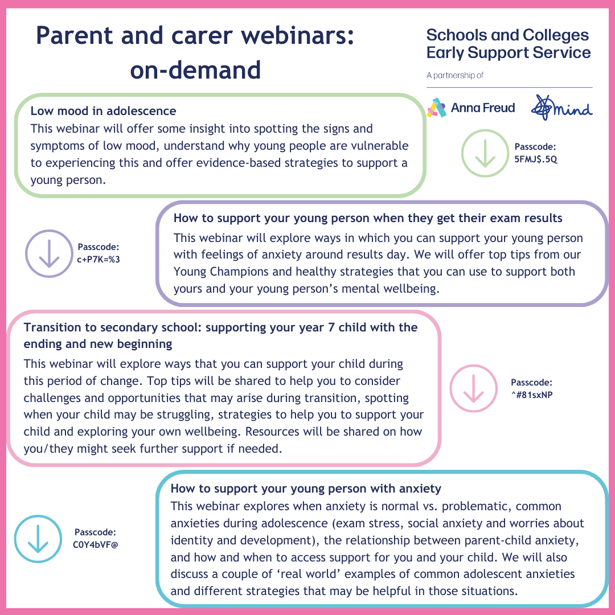
Download here
Download here
Download here
Download here

